**MICROSERVICE ARCHIECTURE AND ITS IMPORTANCE**

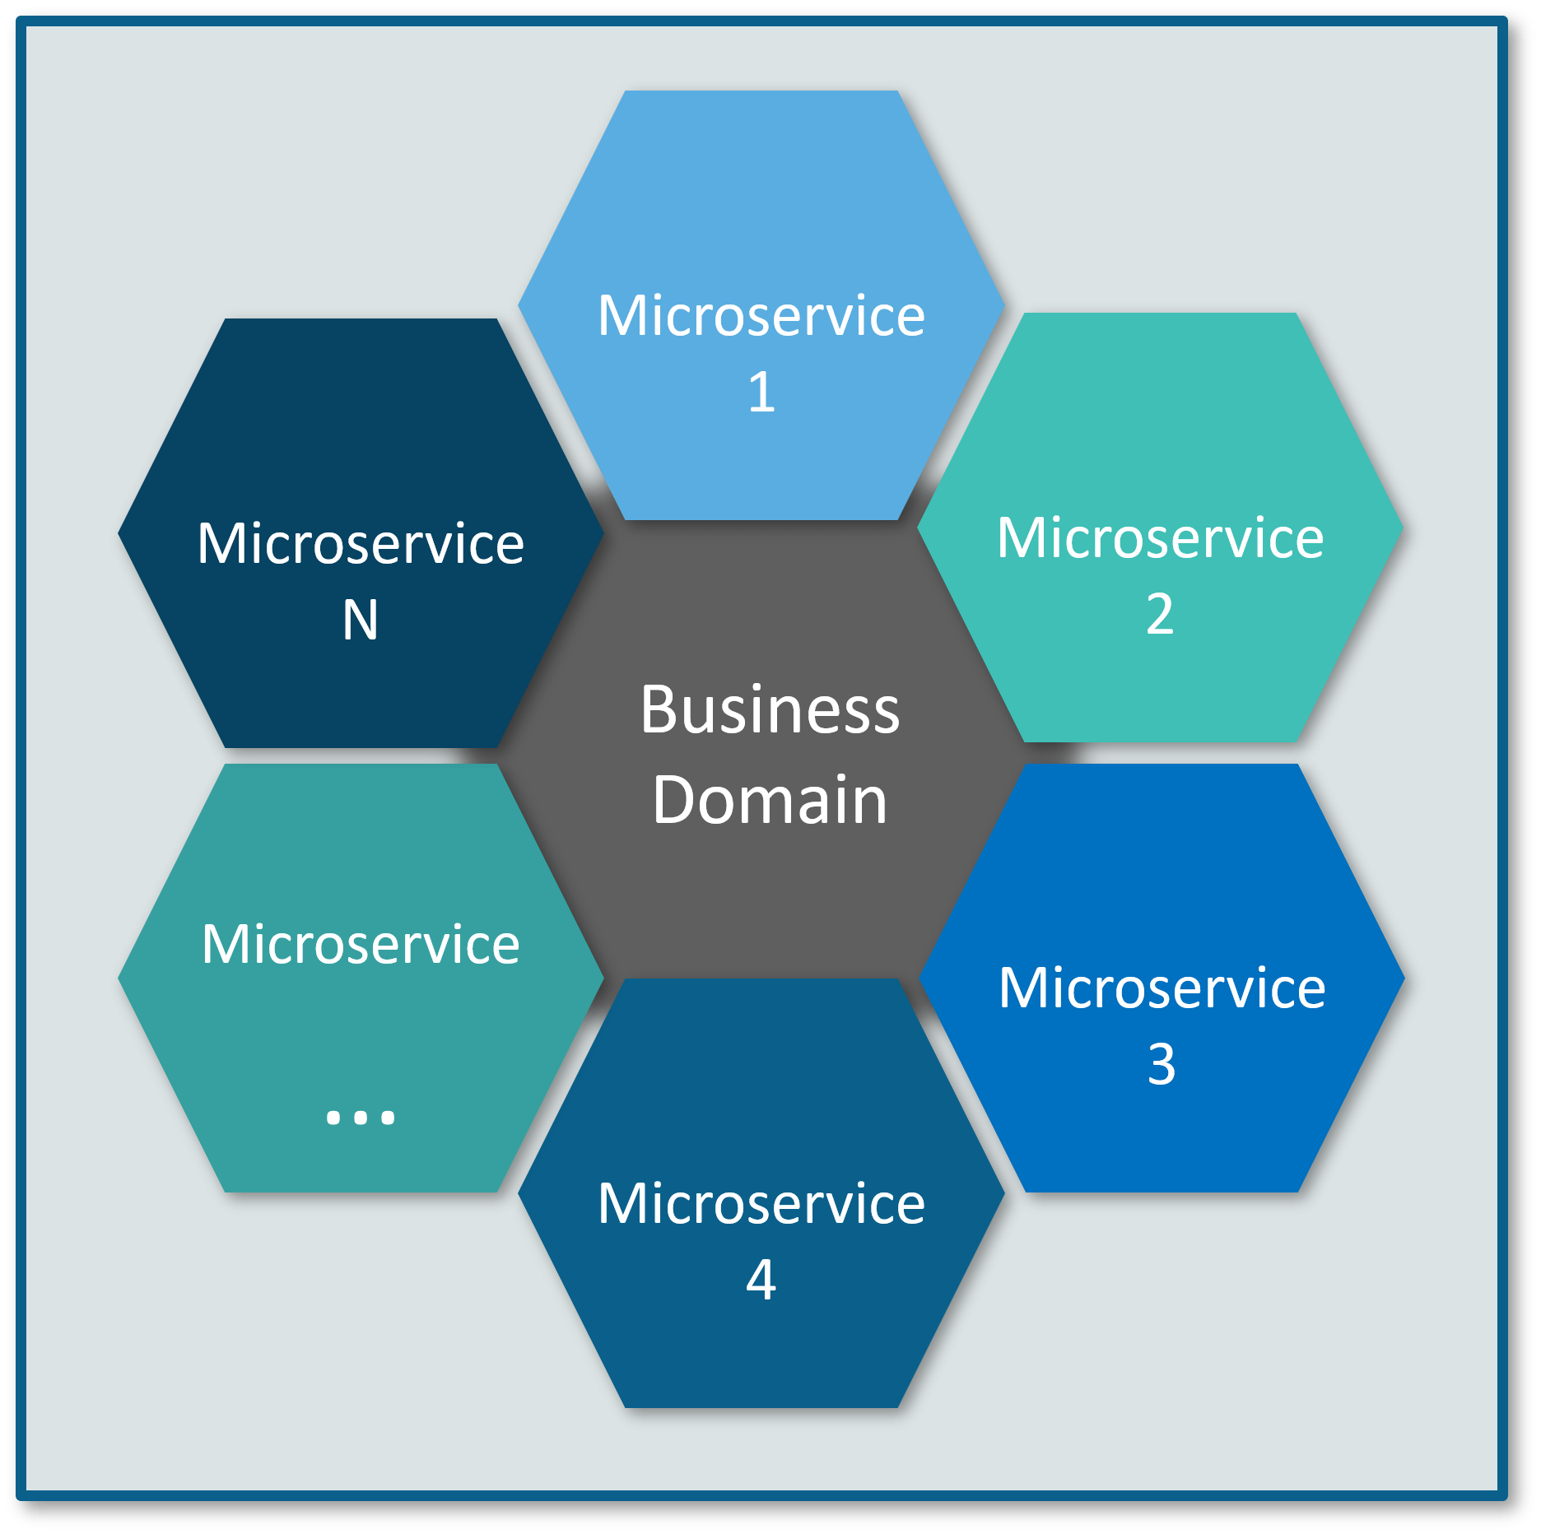

Microservices - also known as the microservice architecture - is an architectural style that structures an application as a collection of services that are

* Highly maintainable and testable
* Loosely coupled
* Independently deployable
* Organized around business capabilities
* Owned by a small team

## **BACKGROUND :**

In early age of computer the writing of code is difficult to scientist. In 1960 the “BASIC” was develop which is general purpose programming language which is much easier than previous language. So, the computer software development is increase rapidly and complexities too, the scientist want to outfit the complexity of software system. In 1972, the modularity concept is introduce which means decompose the huge software system into “Loosely couple and Highly cohesive”. In 1990, the layer architecture developed and the layer architecture consist of Presentation layer, Business layer, Persistence layer and Database layer. In late 2000 the rise of Internet and the companies like FACEBOOK, UBER, NETFILIX and TWITTER went with great innovated idea and want to capture the market and scientist realized that monolithic architecture is not use further anymore.

IMITIATION OF MONOLITHICAL ARCHITECTURE

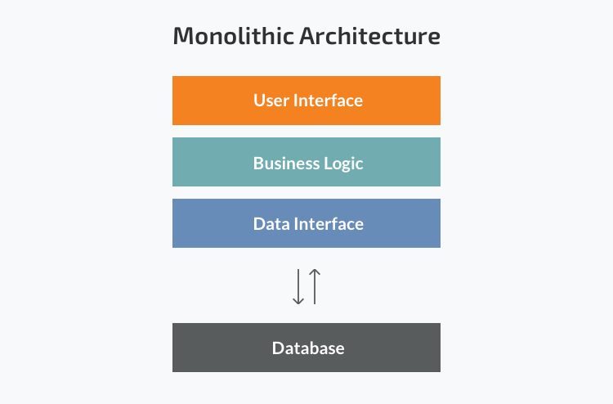

Monolithic application has single code base with multiple modules. Modules are divided as either for business features or technical features. It has single build system which build entire application and/or dependency. It also has single executable or deployable binary.

Monolithical Architecture enjoys in development of web base companies but we need to use different programming language for different platform which are not give by the monolithical architecture because this architecture work’s on single programming language.

Now a day every companies want to upgrade their feature rapidly. Adding a new feature in monolithical architecture is a very huage challenge for the developer’s.

Companies hiring more developer for fast development but never thing about the monolithical architecture has tightly coupled. Due to hiring more developer we need to reduce the communication gap between them.

Lunch of new feature in monolithical architecture is very slow around 6 month to 2-3 year gap. Now companies need small release cycle to up to date there software time by time